***Assignment (1)***

1. Create 2 file in home directory (your user name) with name file1, file2

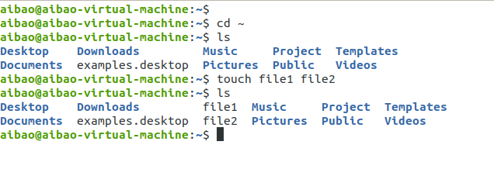

1. Open file1 and write the following text, then save and exit.

Hi

My name is yourname

This is a linux class

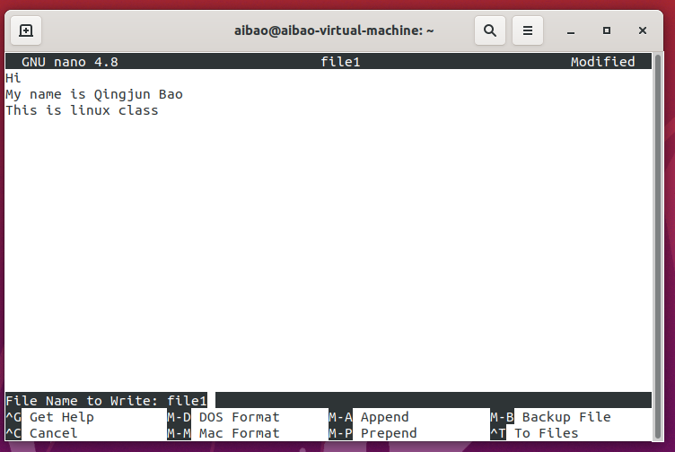

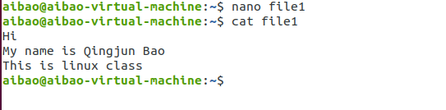

1. Create two directories dir1 and dir2 in the same location in your home directory

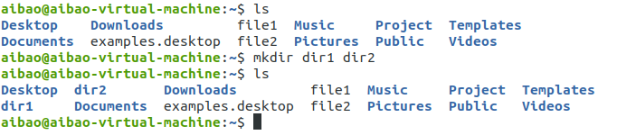

1. Copy file1 into dir2 with a different name ‘report1’



1. Display what is inside report1

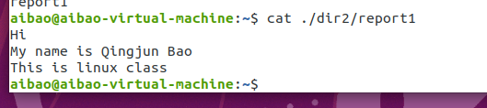

1. Copy dir1 into dir2

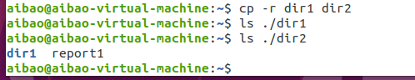

11) Remove file2

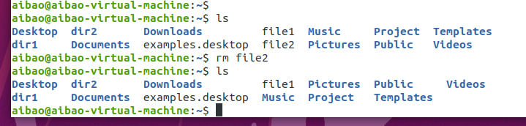

12) Remove dir2

